Assignment 1

OS Lab 110698

11762 Muhammad Kashif

Task 1 a (Binary to Decimal)

#!/bin/bash

echo "Hello world"

echo "Task 1"

echo "Please enter binary number "

read num

dec=0

power=0

while [ $num -ne 0 ]

do

mod=$((num%10))

num=$((num/10))

mod=$((mod\*2\*\*power))

dec=$((dec+mod))

power=$((power+1))

done

echo "Decimal number $dec"

output

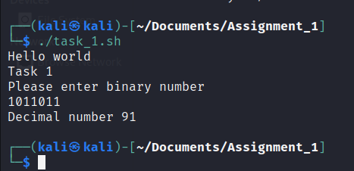

Task 1 b (Grade decider)

#!/bin/bash

echo "Hello world"

echo "Task 2"

echo "Please enter Percentage : "

read num

grade=""

if [ $num -ge 0 ] && [ $num -lt 60 ]

then

grade="F"

elif [ $num -ge 60 ] && [ $num -lt 72 ]

then

grade="C"

elif [ $num -ge 72 ] && [ $num -lt 87 ]

then

grade="B"

elif [ $num -ge 87 ] && [ $num -le 100 ]

then

grade="A"

fi

echo "Your grade is $grade"

Output

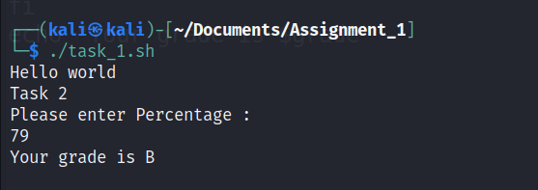

Task 2

#include<stdio.h>

#include<stdlib.h>

int main(){

int\*ptr1;

int\*ptr2;

int \*array;

int a=0;

ptr1 = (int\*)malloc(7 \* sizeof(int));

array = (int\*)malloc(7 \* sizeof(int));

ptr2 = (int\*)malloc(7 \* sizeof(int));

printf("\nEnter number of elements in 1st Pointer:");

for (int i = 0; i <7 ; i++){

scanf("%d",&ptr1[i]);}

for (int i = 0; i <7 ; i++){

printf("%d\t", ptr1[i]);

ptr2[i]=ptr1[i];}

ptr1=realloc(ptr1,6);

printf("\nEnter number of elements in 2nd pointer:");

for (int i = 0; i <6 ; i++){

scanf("%d",&ptr1[i]);}

for (int i = 0; i <6 ; i++){

printf("%d\t", ptr1[i]);}

int num=0;

for (int i =0 ; i<7;i++){

for (int j =0; j<6;j++){

if( ptr1[i] == ptr2[j]){

array[num] = ptr2[j];

num=num+1;}}}

printf("\n");

for (int i = 0; i <num; i++){

printf("%d\t", array[i]);}

printf(" \nNumber of Dublicates %d\t", num);

return 0;}

Output

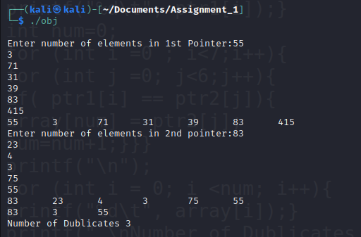

Task 3

#include<stdio.h>

int main(){

int bt[20],bt2[20],wt[20],tat[20],i,n,p[20],p2[20],k,prt[20],prt2[20],t,ct[20], max;

float wtavg, tatavg, temp,j;

printf("\nEnter the number of processes :");

scanf("%d",&n);

printf("\nEnter the size of the time slice --");

scanf("%d",&t);

for (i = 0;i<n;i++){

p[i]=i;

p2[i]=i;

printf("\nEnter Burst Time and Priority for process %d --",i);

scanf("%d %d",&bt[i], &prt[i]);

ct[i]=bt[i];

prt2[i]=prt[i];

bt2[i]=bt[i];}

for(i=0;i<n;i++){

for(k=i+1;k<n;k++){

if(bt[i]>bt[k]){

temp=bt[i];

bt[i]=bt[k];

bt[k]=temp;

temp=prt[i];

prt[i]=prt[k];

prt[k]=temp;

temp=p[i];

p[i]=p[k];

p[k]=temp;}}}

wt[0]= wtavg =0;

tat[0] = tatavg = bt[0];

for (i=1;i<n;i++){

wt[i]= wt[i-1] + bt[i-1];

tat[i] = tat[i-1] + bt[i];

wtavg = wtavg + wt[i];

tatavg = tatavg+tat[i];}

printf("Shortest Job First\n");

printf("\tProcess \t Priority \t Burst Time \t Waiting Time \tTurnaround Time\n");

for(i=0;i<n;i++){

printf("\n\tP%d\t\t%d\t\t%d\t\t%d\t\t%d",p[i],prt[i],bt[i],wt[i],tat[i]);}

printf("\nAverage Waiting Time --%f",wtavg/n);

printf("\nAverage Turnaround Time --%f\n",tatavg/n);

temp = 0;

printf("\nRound Robin");

max = bt2[0];

for (i=1;i<n;i++){

if(max<bt2[i]){

max=bt2[i];}}

for (j=0;j<(max/t)+1;j++){

for (i=0;i<n;i++){

if (bt2[i] != 0){

if (bt2[i] <= t){

tat[i]=temp+bt2[i];

temp=temp+bt2[i];

bt2[i]=0;}

else{

bt2[i]=bt2[i]-t;

temp=temp+t;}}}}

for(i=0;i<n;i++){

wt[i]=tat[i]-ct[i];

tatavg+=tat[i];

wtavg+=wt[i];}

printf("\n\tProcess\t Priority\tBurst Time \tWaiting Time\tTurnAround Time\n");

for(i=0;i<n;i++){

printf("\tP%d \t\t%d\t%d \t\t%d\t\t%d\n",p2[i],prt2[i],ct[i],wt[i],tat[i]);}

printf("\nThe Average Turnaround Time is --%f",tatavg/n);

printf("\nThe Average Waiting time is --%f",wtavg/n);}

Output

